Reviewer 2: Comments below in decreasing order of importance.
We would like to thank the reviewer for their time and review of our manuscript. Below are our responses to their comments.
1. Sensitivity is implicitly limited by effectively late noise in all of the models examined in this manuscript. By "effectively late," I mean either that it is added after signals from the two eyes have been combined or that stochastic signals in the two eyes are perfectly correlated. This implicit limitation stands in distinction to the model of Campbell and Green (1965), in which fluctuations in the two eyes' signals are assumed to be independent. Is there any evidence that sensitivity is, indeed, limited by effectively late noise?

The reviewer is correct that sensitivity in our models is implicitly limited by late noise, as is assumed by all contemporary models of binocular vision, which distinguishes it from the model by Campbell and Green. However, it has been clear for some time now that the proposed architecture by Campbell and Green does not capture the behavioral results of binocular summation. Their model can only return sqrt(2) improvements if the noise from the unstimulated eye is ignored on monocular trials. As participants have no way of knowing which trials are monocular and which are binocular, we can’t effectively predict observer responses with this model. It is conceivable that models could be created by assuming early noise; however, it would be complicated for them to explain the wide range of results that are accounted for by current models, such as the one we present here.
2. Reducing the SSVEPs to SNRs would be sensible if 'noise' were constant across conditions and frequencies. Otherwise, I think that signal and noise should be reported separately. Ideally, the effects of condition and/or frequency on noise as well as signal should be explained.
We appreciate the reviewer’s interest in the study of internal noise and agree that noise can be an interesting aspect to investigate. We use SNRs in this experiment to compare the magnitude of multiple frequencies within a condition. The amplitude spectrum of EEG signals is pink; thus, low frequencies will have a larger amplitude than higher frequencies, which prevents a direct comparison. SNRs circumvent this issue as they are relative measures of amplitude.

We appreciate the concern regarding the potential difference in amplitudes at neighboring frequencies to the fundamental and its harmonics, which may vary across conditions. This could indeed alter SNRs and make their comparison difficult. We conducted permutation tests to ensure sure there are no differences in the amplitude of the noise frequencies used in the denominator of our SNR calculations. As expected, no statistically significant differences in the amplitude of the 10 neighboring frequencies used in the denominator of our SNR calculations were found across conditions (all ps were greater than 0.05). Below is a figure that shows the distribution (across participants) of the noise amplitudes. As you can see, all distributions overlap significantly.
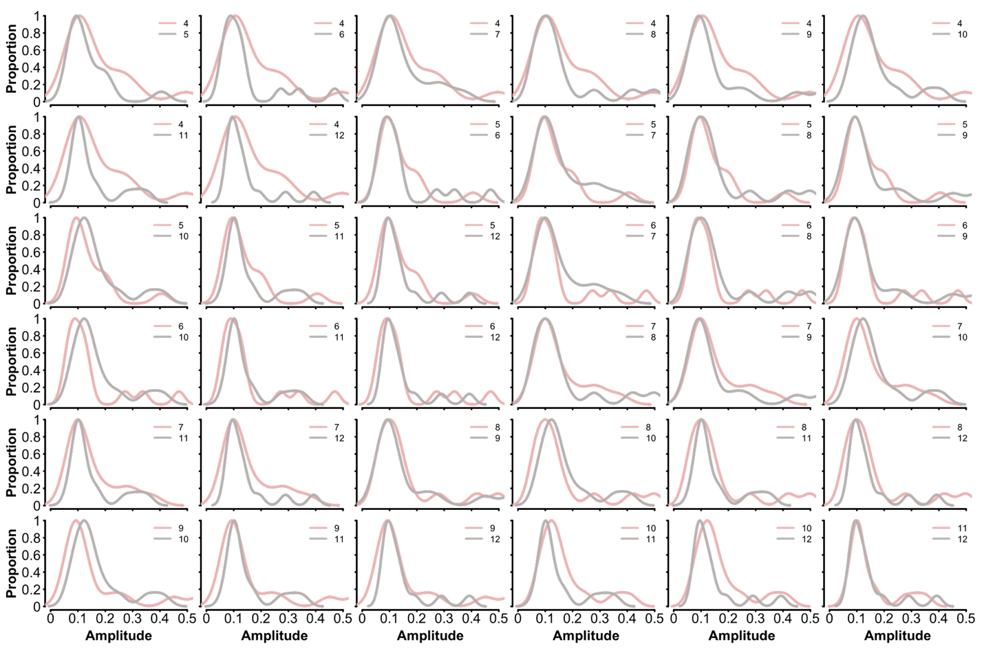

We cannot compare amplitudes across frequencies because the amplitude spectrum of EEG signals is pink, and therefore, low frequencies by default will have greater amplitude than higher frequencies.

We have updated the SSVEP analysis to reflect the absence of difference in noise with the following sentence:

There were no differences in the amplitude of the adjacent bins across experimental conditions.
3. Calculation of AIC requires likelihood estimation. How was that accomplished? It would be nice to know how many free parameters were associated with each model.

The reviewer is correct; AIC is calculated using the likelihood, but one can also estimate the likelihood using the mean square error. This is the method we use in the manuscript. The equation we use is: AIC = 2*k+ n*log(mse) + n*log(2*pi) + n. k refers to the number of parameters in the model, n is the sample size, and mse is the mean square error (sum of the squared differences between model and real data divided by the sample size).
4. Data from all observers seem to have been pooled to achieve significant effects (including p just less than .05). How can we be sure that the sample size of N = 15 wasn't the result of p-hacking?
We thank the reviewer for their comment on our statistical analysis. They are correct; we aggregate observer data into a distribution of SNR values for each condition. Statistical tests compare measures of central tendency for distributions, which means SNR values of our observers must be pooled to build this distribution. As with any data and statistical test, the goal is to estimate the central tendency of a sampling distribution (in this case, the SNR values for various stimulus configurations). The larger the sample size, the better the estimate of central tendency (and the smaller the variance in our estimate will be). This is why we have a sample size of 15 observers. Experiments that use the SSVEP method generally have a sample size of 10 or more. This is to ensure a good estimate of the statistic of interest (e.g., median SNRs).

Additionally, our experiment code, data, processing pipeline, and analysis are all available on the OSF website, and a computationally reproducible version of our manuscript is available on GitHub. Note that this study was conducted before our lab routinely preregistered experiments, and the analysis was conducted many years after data collection. Our analyses did not dictate sample size.
5. Legge (1984a) is cited in reference to Eqn. 1, but I can't find that equation anywhere in Legge's paper.

This was an oversight on our part; the equation is in Legge 1984b. We have changed the citation.
6. "...can improve by a factor of root 2 or more" in the third sentence seems meaningless.

This sentence refers to the effects of binocular summation at threshold, where the doubling of the input increases performance by a factor of 1.41. It is fundamental to the computational description of binocular summation (the non-linearity of summation) and is regularly used as an opening statement in manuscripts that discuss binocular summation.

